Скайп – урок по темі “Generation Gap”

СЗОШ І-ІІІ ступенів №4

11-А клас

2015-2016



Учитель: Забігай Н.В;

учитель вищої кваліфікаційної категорії

Комсомольськ 2015

**Тема: Я, моя сім’я, друзі**

**Підтема: Сімейні відносини. Конфлікт поколінь.**

**Навчальна мета:** - розвивати вміння вести бесіду за тематикою «Конфлікт поколінь. Родинні відносини»;

* активізувати лексичний матеріал в усному мовленні;
* формувати мовленнєві навички по темі уроку;
* тренувати учнів в аудіюванні тексту

**Виховна та розвиваюча мета:**

* розвивати креативне мислення;
* розвивати кругозір;
* сприяти формуванню країнознавчих знань;
* розвивати в учнів інтерес до вивчення англійської мови;
* виховувати в учнів любов та повагу до своєї країни.

**Тип уроку**

Урок формування мовленнєвих вмінь (говоріння та аудіювання)

**Обладнання:** - Smart Board, програма Skype, комп’ютери, Power Point мультимедійні презентації, роздатковий матеріал Macmillan.ua, British Council.org.ua, Busy Teacher.org, Xsplit Broadcaster, відеокамери, мікрофони.

**План уроку:**

І. Мовленнєва розминка.

ІІ. Мотивація навчальної діяльності. Повідомлення теми уроку.

ІІІ. Актуалізація опорних знань

1. Активізація навиків читання та говоріння.
2. Ознайомлення з традиціями та звичаями родин в Україні та Фіджі.

(презентації учнів та гостя з Великої Британії про свої сімейні традиції)

1. Розвиток діалогічного мовлення у режимі S>G
2. Мозковий штурм
3. Розвиток навичок аудіювання
4. Контроль розуміння прослуханого тексту
5. Розвиток креативного мислення
6. Активізація навичок читання – робота у групах
7. Розвиток навичок говоріння у режимі T>Cl, CL>G
8. Підведення підсумків – порівняльна характеристика (Діаграма Вена)
9. Рекомендації щодо домашнього завдання
10. Пісня «Перлина Україна»
11. Feedback (зворотній зв’язок)

**Хід уроку:**

**Мовленнєва розминка**.

**Мотивація навчальної діяльності. Повідомлення теми уроку**

Teacher: *Today we are having an unusual lesson. We have a special guest – Azeem Sahu Khan from Great Britain. Let`s greet him****.***

- Ok, let`s start. The theme of our lesson is “Generation Gap”.

**Активізація навиків читання та говоріння**

I want to begin our lesson with these words. I want you to read and comment them.

When life gives you lemons – make lemonade

If life gives you strict teachers – thank them

If life gives you strict parents – obey them. (Comments of the students)

* Nevertheless your parents are too strict or too kind, they are your family.
* Is having a family very important for every person?

**Ознайомлення з традиціями та звичаями родин в Україні та Фіджі.**

*(Power Point презентації учнів та гостя з Великої Британії про свої сімейні традиції)*

I want you to tell about your family traditions **(students` presentations about their families)**. And now, Azeem, I want you to tell about your family and our students will listen to you and put some questions. **(Presentation from Azeem).**

**Розвиток діалогічного мовлення у режимі S>Guest (**students put additional questions to find out some new information**)**

It`s not a surprise, sometimes even a very happy family can have some problems in relationships.

- So the topic of our lesson is Generation Gap.

**Мозковий штурм** (Answer the questions)

**-** What does the phrase “Generation Gap” mean? (the topic “Generation Gap”)

*- What can make you nervous, annoyed, and disappointed?*

Students answers:

* My clothes
* Problems at school,
* A quarrel with parents,
* When a friend doesn’t want to understand,
* When I can’t find a thing I need,
* Lack of caring and sharing,
* Too much caring,
* When there are a lot of people in one house and you don’t have a chance to be alone, unseen or unheard.

**Розвиток навичок аудіювання** *(Pre-listening exercises)*

* What is the background of teens` problems? (misunderstanding)

Now your task is to listen to the text about the girl`s worries named Ann.

But before listening let`s read and translate some word phrases you`ll come across while the listening

1. To be up to
2. To go through stuff
3. To muck about toiletries
4. To rummage things
5. To keep nagging somebody about something
6. To bug somebody

**Listening (Azeem`s reading)**

One of the worst things about my house is the lack of privacy. If I disappear into my room for some peace, it’s guaranteed that someone will come after me, wanting to know **what I am up to**. The thing is because I share a room with my little sister, I can’t just shut the door, and keep everyone out. She’s always complaining that’s it’s her room, too. Even worse, it means nothing is safe. I guess she **goes through all my stuff**, **mucks about with my toiletries**, and eats the sweets I keep in my room. If I want to keep anything secret, I have to use lock.

Although I’m 15, my parents treat me like a baby. They don’t let me out during the week and if I want to go to a friend’s house at the weekend, they phone up her parents and ask what time I’ll be at home. Dad always asks me about boys, warning me that I’m not allowed to go on real dates. He **keeps nagging me about** homework and studying. He thinks I/m lazy when I sit watching the telly at night.

The other thing that **bugs me** is that I’m treated like an unpaid slave in the house. I have to do the dishes, help with ironing… I wouldn’t object to this if everyone in the house did their fair share, but my brothers only keep their room clean, and my sister just acts like a baby. Mum tells me that she needs the help and I’m the best at doing housework, but that’s because I’m the only one who does it!

I’m going to leave home as soon as I’m old enough. It would be great if I could get a job and a flat when I leave school. I wish I just had one tiny room of my own. My mates always say that I’ll miss my family once I leave, but I doubt that!

**Контроль розуміння прослуханого тексту** *(After – listening activities)*

What problems does Ann face up to?

**Розвиток креативного мислення**

This is Ann. *(Students work with the picture of a girl)*

Give her some piece of advice. (Students` answers).

**Активізація навичок говоріння – робота у групах (матеріал з сайту Macmillan.ua)**

And what about the parents?

**Teacher:** What would you advise the parents to avoid the misunderstanding? You have to split into two groups, read the statements and group them in different categories: advisable, not advisable (forbidden).  **(group work)**

* make children feel low or ignored
* give promises and not to keep them (to break them)
* lose their temper and shout at children
* criticize their children too much and deprive them of self-respect and self-confidence
* punish the children severely
* have favourite(s) in the family, not to treat all the children equally
* give too much freedom to their children
* not to give their children any freedom of choice
* spoil their children in every possible way
* give their children plenty of love and patience
* avoid quarrels and keep their feelings under control
* develop their children’s minds and give them a good education
* teach their children to be decent to other people
* teach their children good manners
* always find time to spend with their children
* hear the children out and discuss their problems
* praise their children when they deserve it.

**Teacher:** While preparing for this lesson and surfing the Internet for the ideas I came across the so called “mommisms”. What do you think this word means?

**“Mommisms” are things your mother said a million times (матеріали з сайту The British Council)**

* *What are the most popular phrases with your mums?*

**“Mommisms”**

- I would never have talked to my mother like that.

- Why? Because I said so, that’s why.

- I’m going to give you until the count of three.

- ‘I don’t know’ is NOT an answer.

- If everyone jumped off a cliff, would you do it, too?

- I’m not talking just to hear my own voice.

- I hope, some day, when you have kids, they’re just like you, then you’ll know.

-Wait until your Father gets home

- If you fall out of that tree and break your leg, don't come running to me.

- Why do you bother asking me a question and then don't bother to listen to the answer?

- Look into my eyes! You are telling lies.

- You’d better not do it again!

**Teacher:** They think that mums nag and lecture their children the most. But believe me dads are not less inventive. I have found expressions used by fathers as well. I am sure you have guessed that they are called “daddisms”.

**What are the most popular phrases with your dads?**

**“Daddisms”**

- Come here, boy.

- This story reminded me of my childhood...

- Stop crying before I give you something to cry about.

- “Can't” means “won't try”

- My dad would unbuckle his belt and whip me with it before I could even think of running away.....  
 - Might tempt fate again...

- You start to worry about your parents’ health.

- and...and....and...........

- Money doesn’t grow on trees.

- What's that you say?

- I am fed up.

- That’s none of your business.

I tried to find either “kiddisms” or “childisms” in the Net and I’ve managed but, unfortunately, they turned out to have other meanings. **“Kiddisms”** are short jokes about kids whereas “**childisms”** mean discrimination towards children and young people. So let’s work out the mostpopular phrases with you.

**“Kiddisms”**

- You never let me stay out late.

- You are never there for me.

- What have I done now?

- I am busy at the moment.

- It’s not my fault.

- I’ll do it later.

- You never let me watch what I want on TV

- I am doing my homework now.

- I couldn’t care less.

- You don’t understand a thing.

- Leave me alone.

- That’s really not fair.

**Підведення підсумків – порівняльна характеристика (Діаграма Вена – матеріали з сайту Busy Teacher.org)**

**Teacher:** - Ok, we`ve found out the problems of Ukrainian teenagers. And what about the youth from the Fiji islands. I want Azeem to tell about them, from his childhood. After listening, we are going to discuss the differences or similarities in Generation Gap problem among the teens from Ukraine and Fiji. We`ll use **the Venn Diagram** to write down the differences and the similarities.

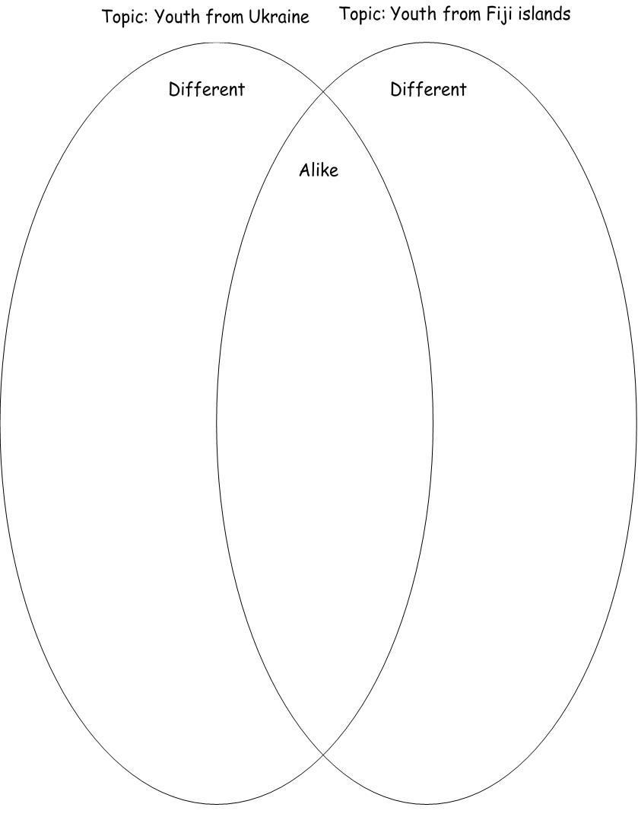

We see that we have …. (Venn Diagram)

**Рекомендації щодо домашнього завдання**

**Homework** – a composition “Generation Gap problem in the world”

**Пісня «Перлина Україна» - відеоролик з сайту You Tube**

- What is necessary to avoid misunderstanding? **(mutual love)**

To be happy means to be loved, to be heard, to be treated as equal. **The main idea of the lesson:** Love each other and everything will be OK. All obstacles will be overcome and all the gentle words will be found and this cruel world will turn to you with a kind smile. Your mother’s smile, your father’s smile, your smile… Azeem, we have a surprise for you – a Ukrainian song “Перлина Україна”.

**Feedback**

* **Have you enjoyed our unusual lesson?**
* **Describe your feelings**
* **Would you like to have another Skype-lesson?**
* **What topic would you like to discuss?**